Company to Demo for

* Top 5
* Maybe interested
* Definitely not interested

USCIS E verify

1.Novartis (drug discovery? Team fit a small phase in the pipeline)

Not only stat, interested in the science part

2.Merck (drug discovery? Team fit a small phase in the pipeline)

3.Seven Bridges (analysis, online platform)(product manager: client facing) (big startup) specific mission: platform

4.Good start genetics (N)(Pre-pregancy team, CS + STAT, know bench)

5.Pfizer (team1: NLP, team2: drug + protein interaction database (maybe))

6.Immuneering (Visa)(Less ML, bioinfo consulting firm, 3rd party, size <10)

7.Evelo (N)(New company, immune-therapy + micro bio, not sure about product)

8.Vertex (data visualization +NLP team)

9.Schireson (N)(50-100 ppl, consulting)

10.Wayfair (ML, market team, client facing, strategy)

11.Tamr

12.Amazon Alexa

13. Amazon Search Technologies

14. CVS

15. MGH

16. Bitsight

17. PatientsLikeMe (N)

18. Vectra

19. Cinch (N)

1. Merck (Jennifer)

Health informatics tech

Clinical trial data

Payment report, reimbursement for insurance

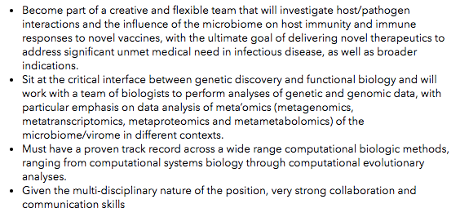

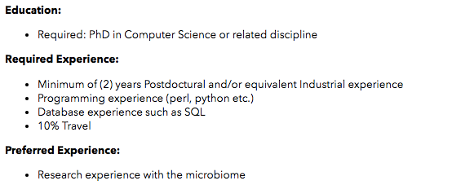

Not directly

Several groups hiring?

2. MGH visit

Center for clinical data science

1-2?

3. Seven Bridges

6-7?

4. Vertex

2?

5. Good start genetics

1-2?

6. PatientsLikeMe

Not interested

7. Amazon Alexa

Needs a lot

8. Tamr

Needs a lot (field scientist, DS)

9. Pfizer

2?

10. Novartis

Two teams

11. Wayfair

Needs a lot

12. Vectra

Don’t like it

13. Schireson

2-4?

14. Bitsight

2-3?

Immuneering

CVS

Evelo

Cinch